Butte County 2020 RTP, Air Quality Conformity Analysis & Determination, Sustainable Communities Strategy, and Program Environmental Impact Report

The RTP/SCS is Butte County’s long range metropolitan transportation plan for each mode of transportation. The plan identifies financial projections through 2040 and the BCAG Board of Directors’ priorities on specific projects can be accomplished. The plan then quantifies the air quality impacts to ensure Butte County is in compliance with its air quality requirements. This long range “plan” can be amended at any time by the BCAG Board.

The RTP/SCS then serves as a foundation for the development of the shorter “action” plans called the Regional Transportation Improvement Program (RTIP), which satisfies California transportation planning requirements, and the federal counterpart referred to as the Federal Transportation Improvement Program or (FTIP) for all transportation projects that require federal approval or are “regionally significant.

A recent addition to the RTP/SCS is the Sustainable Communities Strategy (SCS), first included as an element of the 2012 RTP in response to Senate Bill 375 - the Sustainable Communities and Climate Protection Act of 2008. The SCS is intended to reduce the passenger vehicle greenhouse gas emissions associated with the plan.

All information pertaining to this project will be posted at the BCAG website at: http://www.bcag.org/Planning/RTP--SCS/index.html

Why Public Input?

A key part of BCAG’s transportation planning process is to involve the public and solicit input. Public input is very important for the decision making process. The public’s knowledge and perspective adds to the overall understanding of the transportation needs of the region. Therefore, throughout the development of the 2020 RTP and SCS, BCAG goes to the community to seek input keeping the public informed. Your comments and concerns will be documented as part of the process.

The RTP/SCS also serves as documentation for the BCAG Board’s priorities for regional transportation funding to Butte County. As such, it is very important to be involved in the transportation decision-making process.

How Do I Provide Input?

Providing input is easy. Simply write BCAG a letter and mail it to 326 Huss Drive, Suite 150, Chico CA, 95928, by email at igarcia@bcag.org or by phone at 530-809-4616. You can also use the back of this sheet, and mail it in or drop it off at the end of the public meeting. If you have any questions, please direct them to Mr. Ivan Garcia at the number or email identified above.

Thank you for your input.

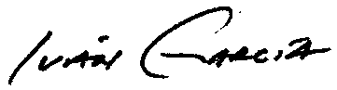
Sincerely,

Iván García
BCAG Programming Manager
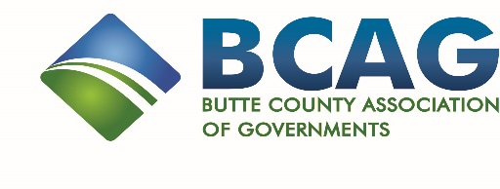

PLEASE USE THE FOLLOWING SPACE TO PROVIDE INPUT. THANK YOU VERY MUCH FOR YOUR PARTICIPATION.

Your Name and Address (optional):

Mail /Drop off or Fax to:
BCAG
326 Huss Drive
Suite 150
Chico CA 95928
FAX: 530-809-4616
www.bcag.org

Contact Ivan Garcia at:
(530) 809-4616 or via email at: igarcia@bcag.org for any questions or comments

BUTTE COUNTY ASSOCIATION OF GOVERNMENTS

2020 REGIONAL TRANSPORTATION PLAN/ SUSTAINABLE COMMUNITIES STRATEGY (RTP/SCS) AND
PROGRAM ENVIRONMENTAL IMPACT REPORT (EIR)

